National Economics University

-----------------

Bachelor of Financial Technology Program

Intake 62

Topics in Portfolio Management

Overview of VCBF-BCF

|  |  |
| --- | --- |
| Group 1 | |
| Name: Vũ Thùy Dương | Student ID: 11204959 |
| Name: Nguyễn Đức Long | Student ID: 11202350 |
| Name: Nguyễn Đăng Quang | Student ID: 11206699 |
|  |  |

Hanoi, 9/2023

# Table of Content

**Table of Content 2**

**Chapter 1: Vietcombank Fund Management Company Limited (VCBF) 3**

1. Development History 3

2. Subsidiary Funds 5

**Chapter 2: VCBF-BCF Fund 5**

1. Basic Information 5

2. Fees 6

3. Investment Strategy 8

4. Portfolio Allocation and Performance 9

**Chapter 3: Portfolio Optimization and Compare 14**

1. Portfolio Theory 14

Markowitz’s Portfolio Theory 14

The Capital Allocation Line 16

Portfolio Performance Analysis 17

2. Stocks Selection 18

3. Stocks Correlation 21

4. Portfolio Optimization (GMV, Optimal, Equal-weight) 22

Equally-Weighted Portfolio 23

Global Minimum Variance Portfolio 25

Optimal Portfolio 29

5. Performance Analysis (Key Performance Indicators) 33

**Conclusion 36**

# Chapter 1: Vietcombank Fund Management Company Limited (VCBF)

Established on December 2, 2005, under license number 06/UBCK-GPHĐQLQ issued by the State Securities Commission, Vietcombank Securities Investment Fund Management Company Limited ("VCBF") is a joint venture between the Joint Stock Commercial Bank for Foreign Trade of Vietnam ("Vietcombank") and the multinational investment group Franklin Templeton Investments ("FTI"). Franklin Templeton Investments is a globally renowned financial investment group and a pioneer in investing in emerging markets. Together with Vietcombank, a leading financial institution in Vietnam, they formed this venture.

With 16 years of operations in Vietnam, VCBF has effectively managed assets for many major Vietnamese and foreign conglomerates. As one of the best-performing funds in Vietnam, VCBF manages total assets of over 190.3 million US dollars as of March 31, 2022.

## 1. Development History

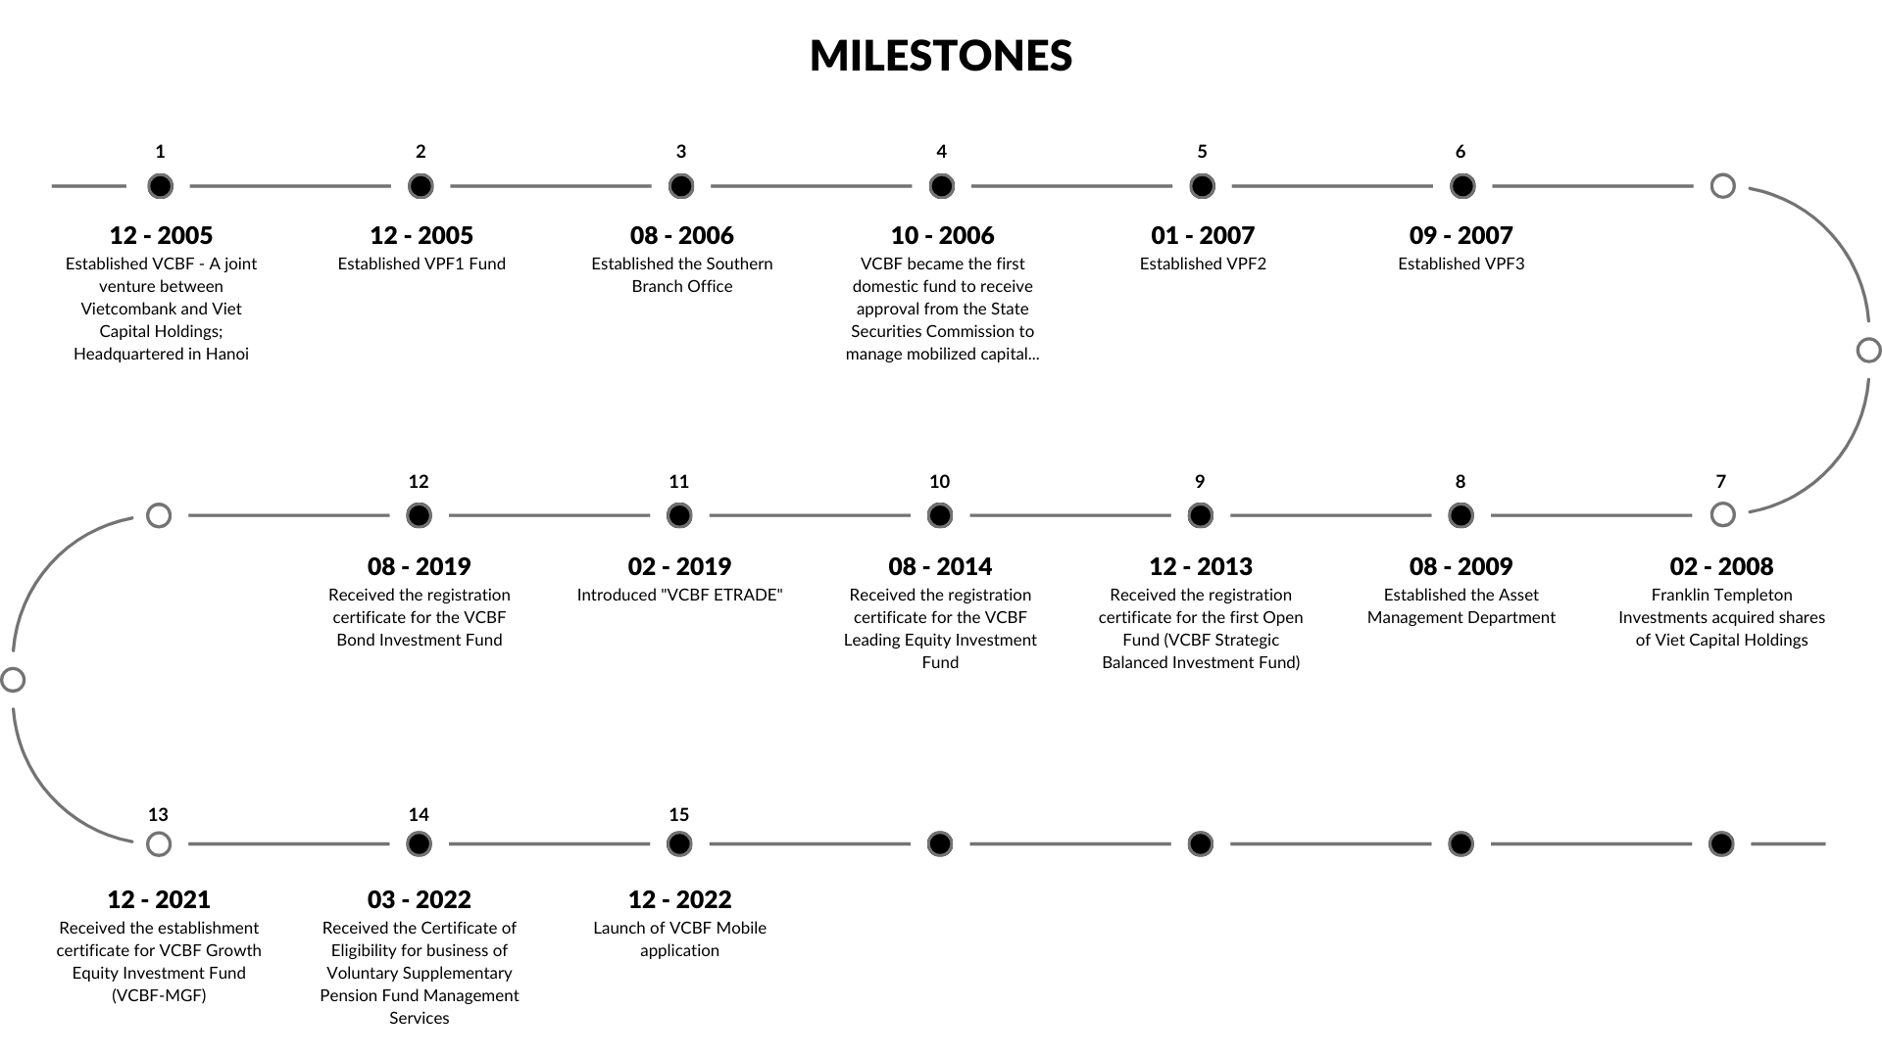

From its inception, Vietcombank Securities Investment Fund Management Company Limited, popularly known as VCBF, has charted a stellar trajectory in the investment fund management industry in Vietnam. Founded in December 2005 as a synergistic alliance between the Joint Stock Commercial Bank for Foreign Trade of Vietnam (Vietcombank) and Viet Capital Holdings, the inception of VCBF marked the birth of a new era in Vietnam's financial sector. The headquarters of this formidable joint venture was established in Hanoi.

A year into its operations, in August 2006, VCBF broadened its operational horizon by setting up the Southern Branch Office, catering to a diverse clientele, and strengthening its foothold in the Vietnamese market. Merely two months later, in October 2006, VCBF achieved a groundbreaking feat by becoming the first domestic fund to garner the nod of approval from the State Securities Commission to manage mobilized capital, showcasing its credibility and competence.

2007 saw further expansion in its operations, with the establishment of VPF2 in January and VPF3 in September. This period of expansion and growth saw a pivotal moment in February 2008 when the global investment juggernaut Franklin Templeton Investments recognized the potential of VCBF and acquired shares of Viet Capital Holdings.

In August 2009, understanding the need for specialized expertise in asset management, VCBF instituted the Asset Management Department, which would later become instrumental in launching and managing numerous investment funds.

By December 2013, VCBF took a significant leap by receiving the registration certificate for its first Open Fund - the VCBF Strategic Balanced Investment Fund. This was closely followed by the establishment of the VCBF Leading Equity Investment Fund in August 2014.

With an eye on technological advancements and to cater to the evolving needs of its clientele, VCBF introduced "VCBF ETRADE" in February 2019, streamlining its operations and rendering them more accessible to its customers. Later that year, in August 2019, VCBF further diversified its portfolio by obtaining a registration certificate for the VCBF Bond Investment Fund.

The company's dynamism and commitment to expanding its range of offerings continued to be evident as recently as December 2021, when it successfully received the establishment certificate for the VCBF Growth Equity Investment Fund (VCBF-MGF). The year 2022 began with a nod of recognition from the authorities when VCBF received the Certificate of Eligibility for the business of Voluntary Supplementary Pension Fund Management Services in March. Furthermore, understanding the significance of mobility and convenience in today's fast-paced world, VCBF launched its Mobile application in December 2022, ensuring that its services are just a tap away from its customers.

## 2. Subsidiary Funds

VCBF offers numerous favourable opportunities for investing in the Vietnamese market. This company manages four open funds: VCBF Strategic Balanced Investment Fund, VCBF Top Equity Investment Fund, VCBF Bond Investment Fund, and VCBF Growth Equity Investment Fund.

* VCBF-BCF: VCBF Strategic Balanced Fund ("VCBF-BCF fund") flexibly allocates assets according to a defensive or growth investment strategy depending on available investment opportunities at different times. Under normal market conditions, this fund will invest 50% of net asset value (NAV) in stocks and 50% in fixed-income assets with good credit quality.
* VCBF-BCF: VCBF Premier Equity Fund (“VCBF-BCF fund”) invests up to 100% of net asset value (NAV) in listed stocks, mainly in stocks with large market capitalization and good liquidity.
* VCBF-MGF: Assets of VCBF Growth Stock Fund (VCBF-MGF) are invested up to 100% in stocks of companies with medium-capitalization and high growth potential.
* VCBF-FIF: VCBF Bond Investment Fund ("VCBF-FIF Fund") is an open-end fund with 100% of the Fund's assets invested in bonds of good credit quality.

To be able to analyze in detail and thoroughly, we decided to focus on only one investment fund under VBCF instead of going into all four funds. In this research, we decided to choose the VCBF-BCF fund. The next part will discuss this fund’s detailed information and investment strategy.

# Chapter 2: VCBF-BCF Fund

## 1. Basic Information

|  |  |
| --- | --- |
| Basic Information of VCBF-BCF | |
| Abbreviation | VCBF-BCF |
| Date of establishment | 22/08/2013 |
| License no | 13/GCN-UBCK |
| Supervisory bank | Standard Chartered Bank |
| Audit | Ernst & Young |
| Distributor | VCBF, SSI, VCBS, FMARKET |

As of 2023, September 14, VCBF-BCF has the following financial information:

|  |  |
| --- | --- |
| Net asset value | 406,422,236,659 VND |
| Net asset value/ETF | 30,372.56 |
| Net asset value changed compared to the previous period | 1.40% |
| Profit rate from the beginning of the year | 25.87% |
| Highest net asset value/ETF (52 weeks) | 30,655.61 |
| Lowest net asset value/ETF (52 weeks) | 21,439.31 |
| Number of fund certificates in circulation | 13,381,229.02 |
| Ownership ratio of foreign investors * | 21.14% |
| Operating expense ratio (%) * | 2.34% |
| Category turnover rate (%) * | 38.54% |
| Total category * | 26 stocks |

## 2. Fees

VCBF-BCF Tactical Balanced Fund (VCBF‐BCF)

|  |  |  |
| --- | --- | --- |
| **No.** | **Services** | **Fee** |
| 1. | Opening account | Free |
| 2. | Online trading services | Free |
| 3. | Subscription orders: |  |
| · VND1,000,000 to VND1,000,000,000 | 0.5% |
| · More than VND1,000,000,000 to VND5,000,000,000 | 0.3% |
| · More than VND5,000,000,000 | Free |
| 4. | Redemption orders: |  |
| · Holding Period: 1 month or less | 3.0% |
| · Holding Period: More than 1 month to 12 months | 1.0% (1.4% for SIP)** |
| · Holding Period: More than 12 months to 24 months | 0.5% |
| · Holding Period: More than 24 months | Free |
| 5. | Switching orders | The Switching Fee is the difference between the Subscription Fee of the destination Fund and the Subscription Fee of the leaving Fund at the time the switch is executed if this difference is higher than zero. |
| 6. | Transfer orders | VND300,000/transaction |
| 7. | Subscription Fees applied for Systematic Investment Plans (SIP) | Free |

*\* Operating and administration expenses, including management fees, the supervisory bank fees, custody fees, fund administration fees, registrar and transfer agency services fees, auditor fees, allowance of the fund representative board, and other expenses, will be charged as expenses to the Fund*

*\*\* A redemption fee of 1.4% is applied for aption order withholding period of more than 1 month to 12 months since the SIP inception.*

*SIP redem*

## 3. Investment Strategy

VCBF-BCF Fund is a strategic balanced fund that aims for long-term profits via principal growth and income generation. Under normal circumstances, the fund allocates investments up to 100% of net asset value (NAV) in listed stocks, mainly in stocks with large market capitalization and good liquidity.

Investment Goal: The investment objective of the Fund is primarily to provide medium to long-term capital appreciation. This means the fund is geared toward producing a return on its investments over an extended period rather than seeking short-term gains. The Fund follows a blend of value and growth style of investing.

Investment Strategy:

* Diverse Portfolio: The Fund will primarily invest in a diversified portfolio of stocks listed on the Ho Chi Minh Stock Exchange (“HSX”) and the Ha Noi Stock Exchange (“HNX”), which have a large market capitalization and are liquid. Stocks with large market capitalization are considered as those with a market capitalization larger than the hundredth largest stock listed on the HSX. Balanced Asset Allocation: Under typical market conditions, the fund seeks a 50-50 split between stocks and fixed-income assets. This balanced approach provides a blend of growth potential (from stocks) and stability (from bonds).
* The fund follows a blend of value and growth style of investing.
* Bottom-Up Approach:
  + This strategy involves analyzing individual companies in great detail, from their financial health to their business strategies. The fund's investment team even meets with a company's executive board to get a comprehensive understanding.
  + After understanding the company, the team then looks at the broader industry to understand where that company stands in relation to its peers.
  + Lastly, the macroeconomic conditions of both Vietnam and the world are considered to understand larger trends and impacts on the business.

## 4. Portfolio Allocation and Performance

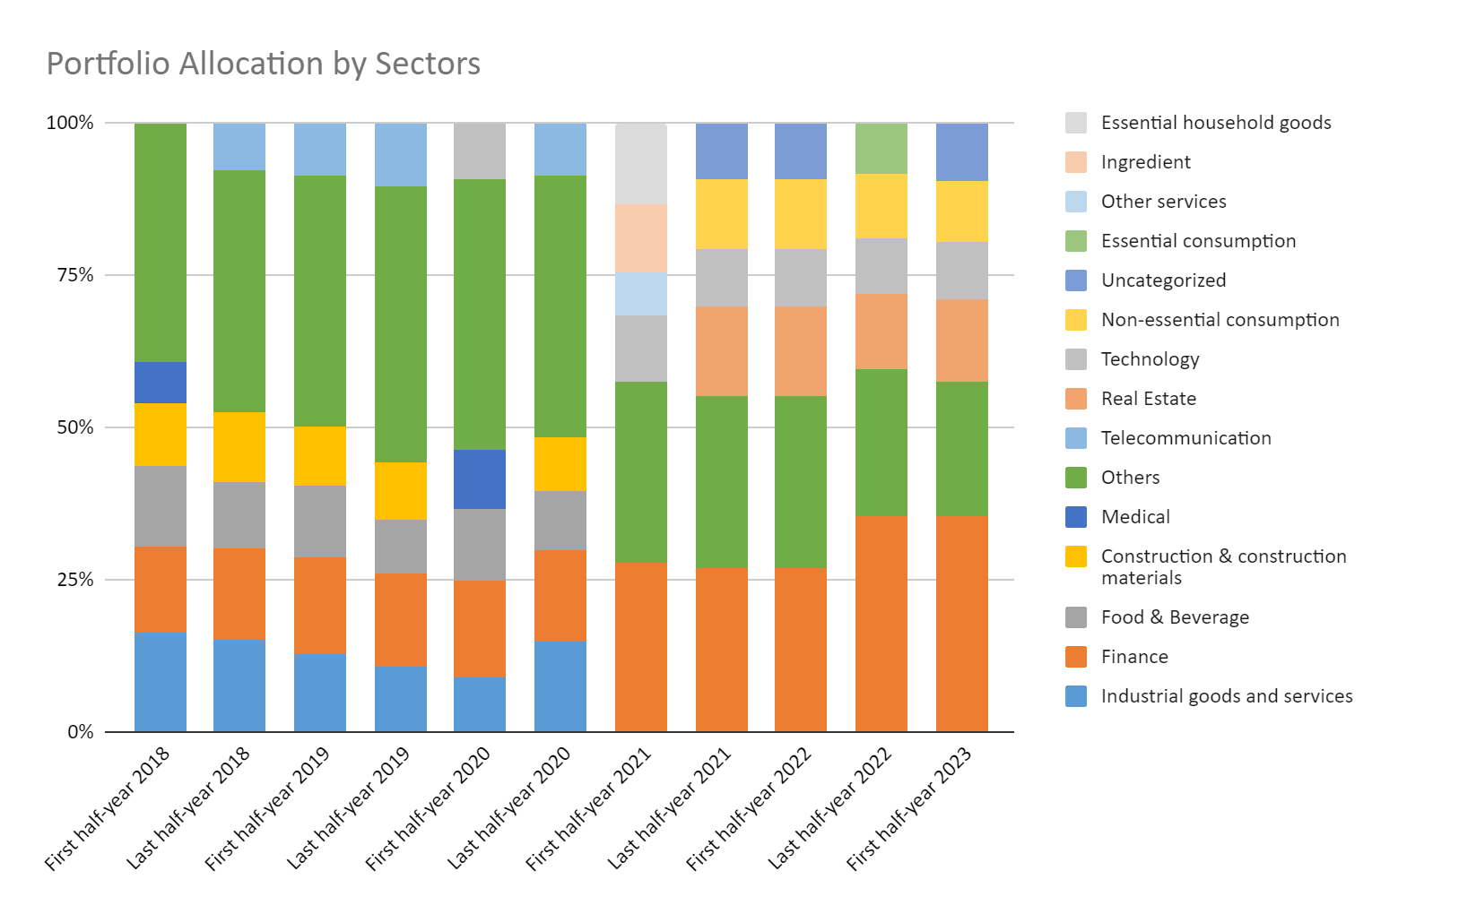

The data illustrates the fluctuating allocation percentages across different sectors within a fund's investment portfolio from the first half of 2018 to the first half of 2023.

Initially, in the first half of 2018, the “Industrial goods and services” sector enjoyed the heaviest allocation at 16.31%, which faced a steady decline until the latter half of 2019, reaching 10.59%. Interestingly, it saw a significant rebound in the latter half of 2020 with 14.70%. However, by 2021, this sector was no longer among the top-listed ones, indicating a marked shift in portfolio priorities. This realignment can be partly attributed to the challenges in 2021. Industrial production in the third quarter confronted several hurdles due to the relentless Covid-19 pandemic, with areas housing major industrial zones being significantly affected due to extended social distancing measures. Consequently, the added value in the industry for the third quarter plummeted by 3.5% year-on-year. This trend was further mirrored in the GDP figures for Q3/2021, where the industrial and construction sector saw a decrease of 5.02%, and the service sector faced a steeper decline of 9.28% compared to the same period in the previous year.

The 'Finance' sector maintained a stable presence throughout the period, initiating at 14.15% in early 2018 and seeing an overall increase. specially by the first half of 2021, it commanded a dominant 27.70% of the allocation, nearly doubling its stake from 2020. This growth mirrors the broader financial landscape. In 2021, net profits of companies across the three primary exchanges (HOSE, HNX, UPCOM) surged by 49.5%. Additionally, the pre-tax profits of 29 key commercial banks, which together held a substantial 80% of the market share, escalated by nearly 32%.

Another notable trend is the decline of 'Food & Beverage', which started at 13.29% in 2018 and then gradually diminished to 10.00% by the first half of 2023. Simultaneously, the 'Medical' sector, which held a 6.61% allocation in early 2018, disappeared from the top sectors by late 2018, only to re-emerge briefly in the first half of 2020 at 9.60% and then vanish again. This may hint at tactical portfolio adjustments, possibly in response to short-term market conditions, as the Consumer Price Index (CPI) for medicine and medical services in the second quarter of 2021 increased by 3.36%.

By 2021, the investment landscape seems to have experienced a significant transformation. New sectors, such as 'Technology' and 'Real Estate', began to emerge. Technology, entering in 2020 at 9.30%, and Real Estate, starting in the latter half of 2021 with 14.60%, both remained consistent contenders in the subsequent years. The category labeled 'Uncategorized' also started to emerge in late 2021 and has been a part of the portfolio ever since.

Throughout the period, the 'Others' category maintained a high and steady presence, albeit with a gradual decrease from 39.44% in early 2018 to 22.00% by 2023, indicating a clearer strategy and more specific sectoral focus over time.

Thus, the fund's investment strategy has evolved significantly from 2018 to 2023. There's a clear move towards sectors such as 'Finance', 'Real Estate', and 'Technology' while reducing the emphasis on previously favored sectors such as 'Industrial goods and services' and 'Food & Beverage'.

The performance of VCBF-BCF from 2014 to 2022 reveals a notably volatile trajectory. After a dip in 2014, the fund exhibited resilience with three consecutive years of positive returns, peaking impressively in 2017 with a 37.39% gain. However, this growth was interrupted by a significant decline in 2018, followed by a mixture of performances in subsequent years. Particularly eye-catching is the robust 38% profit in 2021, which starkly contrasted with the significant downturn of -18.08% in 2022. While the fund has demonstrated an ability to deliver substantial profits over certain periods, the pronounced fluctuations, especially the recent decline, emphasize the need for potential investors to gauge their risk appetite and evaluate the fund's alignment with their long-term financial goals.

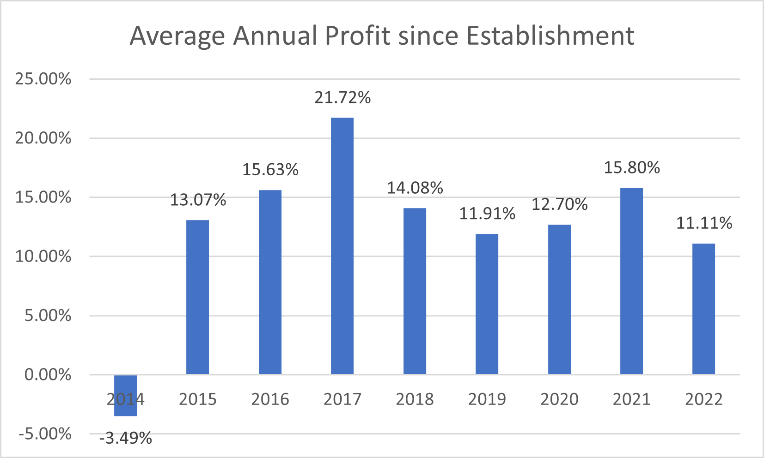

The fund's trajectory, as represented by its average annual profit since its establishment, indicates a generally upward-trending performance, especially in the early years. Beginning with a challenging year in 2014 at -3.49%, the fund experienced substantial improvement, reaching an average profit of 21.72% by 2017. This apex signifies a remarkable compounded growth over its existence up to that point. However, post-2017, while the average profit remains positive, there's a noticeable contraction. The average profit decreased to 14.08% in 2018, though it has managed to stay above 10% in the subsequent years, highlighting sustained yet milder performance. The dip in 2022, bringing the average down to 11.11%, suggests recent challenges or underperformance. Overall, VCBF-BCF showcases a capacity for strong growth, particularly in its earlier years, but potential investors should note the tapering momentum in recent times and consider whether the fund aligns with their investment outlook.

In addition, we can assess the fund's performance against the market benchmark. VCBF-BCF, which invests in highly liquid, large-cap listed equities, references its performance to the VN100 Index. This index comprises the top 100 stocks on the HSX in terms of capitalization and liquidity. For the fund's performance, we'll examine the historical NAVPS (Net Asset Value per Share) data of VCBF-BCF. The NAVPS is determined by dividing the Net Asset Value by the fund's Outstanding Shares. This data spans from 2019 to September 22, 2023. The graph below illustrates the cumulative daily returns of both VCBF-BCF and the VN100.

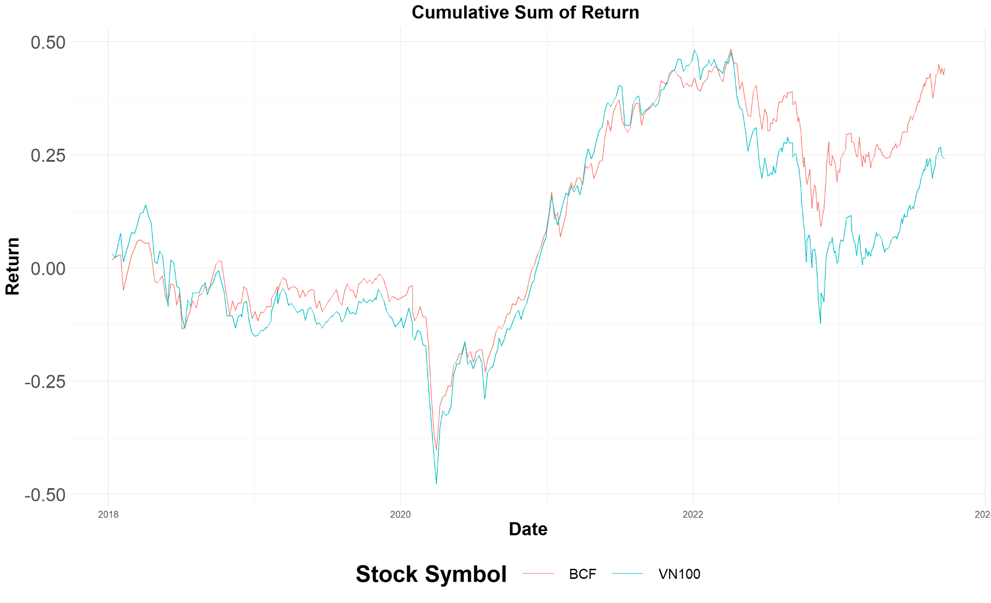

Throughout the observed period, VCBF-BCF consistently exhibited superior returns compared to the VN100 Index, with its cumulative trajectory predominantly surpassing the market. The onset of 2020 saw both the VCBF-BCF and the VN100 experience a precipitous decline, largely attributed to the market disruptions caused by the COVID-19 pandemic. However, a subsequent recovery culminated in peak performances in 2022, with both reaching cumulative returns nearing 50%. After this zenith, a slight pullback was evident, with the VN100 Index witnessing a more pronounced downturn, touching as low as -0.1%. By the conclusion of the period, VCBF-BCF sustained its strong position, with returns hovering around 50%, while the VN100 Index managed to recuperate only to about half of its peak performance.

# 

# 

# Chapter 3: Portfolio Optimization and Comparison

## 1. Portfolio Theory

The portfolio optimizing process of this report will follow closely with Markowitz’s Portfolio Theory, which will be discussed next.

### Markowitz’s Portfolio Theory

Markowitz’s Portfolio Theory, also known as Modern Portfolio Theory (MPT), is a groundbreaking mathematical framework that revolutionized the field of finance and investment management. Developed by Harry Markowitz in 1952, the theory introduced the concepts of diversification, asset correlation, and portfolio optimization, providing investors with a systematic approach to constructing optimal portfolios by balancing risk and return. The MPT is a practical method for selecting investments in order to maximize their overall returns within an acceptable level of risk.

Before the advent of Markowitz Portfolio Theory, investment analysis primarily focused on individual asset selection, with investors seeking to identify and invest in securities that would generate the highest returns. However, this approach did not consider the overall risk of the investment portfolio, leading to potential losses when individual assets underperformed. Harry Markowitz's seminal work, "Portfolio Selection," published in The Journal of Finance in 1952, introduced the notion that investors should consider not only the expected return of each asset but also the portfolio's overall risk. This theory's fundamental concepts include the following:

* **Diversification:** Markowitz's Portfolio Theory emphasizes the importance of diversification in reducing risk within an investment portfolio. By investing in a variety of assets that do not move in perfect tandem, investors can minimize the impact of individual asset performance on the overall portfolio. Diversification helps spread risk across different investments, reducing the potential for significant losses when one or more assets underperform.
* **Asset Correlation:** The theory takes into account the correlation between assets in a portfolio. Asset correlation is a measure of how two or more investments move in relation to each other. If two assets are positively correlated, they tend to move in the same direction, while negatively correlated assets move in opposite directions. Markowitz demonstrated that combining assets with low or negative correlations could help reduce the overall portfolio risk without sacrificing expected returns.
* **Portfolio Optimization:** The central idea of Markowitz's Portfolio Theory is the concept of portfolio optimization, which involves finding the optimal combination of assets that provides the highest expected return for a given level of risk or the lowest level of risk for a given expected return. Markowitz introduced the concept of the Efficient Frontier, a curve that plots the optimal portfolios offering the best risk-return trade-offs for investors. By constructing portfolios that lie on the Efficient Frontier, investors can achieve the most favorable balance between risk and return. A graph of an arbitrarily Efficient Frontier can be shown below. All the points below this curve are possible portfolios; however, investing in one is considered undesirable because it does not maximize returns for a given level of risk.

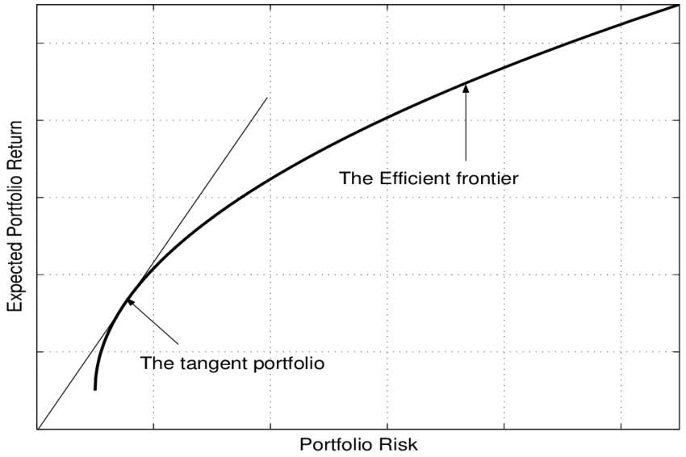

While it is one of the most important and influential theories regarding designing investment portfolios, there are several assumptions and limitations associated with Markowitz's Portfolio Theory, which as follow:

1. Returns from the assets are normally distributed.
2. The investor making the investment is rational and will avoid all the unnecessary risks associated.
3. Investors will give their best in order to maximize returns for all the unique situations provided.
4. All investors have access to the same information.
5. The cost of taxes and trading is not considered when making decisions.
6. All the investors have the same views on the rate of return expected.
7. The single investors alone are not sizable and capable enough to influence the prices prevailing in the market.
8. Unlimited capital at the risk-free rate of return can be borrowed.

While these assumptions provide a solid foundation for the development of the theory, they may only sometimes hold true in the real world. Market inefficiencies, investor irrationality, taxes, and transaction costs can influence investment portfolio performance and the applicability of Markowitz’s Portfolio Theory. Additionally, the theory assumes that asset returns follow a normal distribution, which may not accurately represent the actual distribution of returns in some cases.

NEXT SLIDE

### The Capital Allocation Line

The Capital Allocation Line (CAL) is a line that graphically depicts the risk-and-reward profile of assets and can be used to find the optimal portfolio. It represents the relationship between the risk and return of a combination of a risk-free asset and a risky portfolio. In other words, CAL demonstrates how an investor can allocate their capital between a risk-free asset (such as Treasury bills) and a diversified portfolio of risky assets to achieve different expected return levels based on risk tolerance.

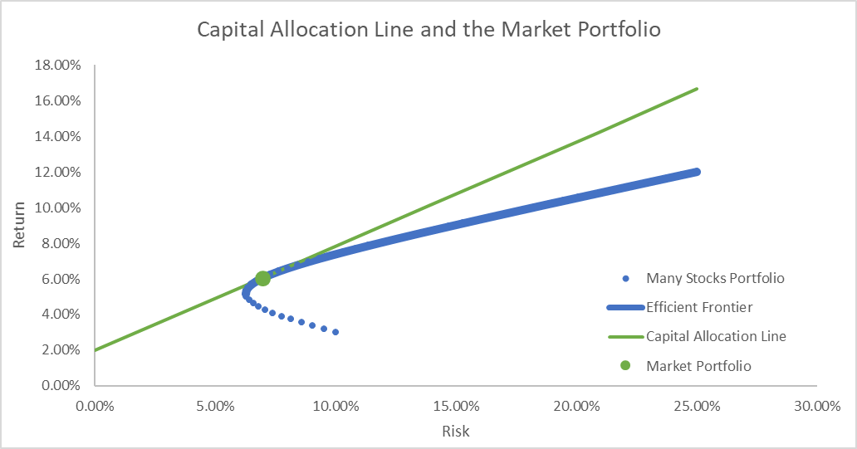

As can be seen from the graph above, the CAL is a straight line that starts at the risk-free rate on the vertical axis (y-axis) and connects it to the expected return and risk (standard deviation) of the risky portfolio on the risk-return plane. The slope of the CAL represents the reward-to-variability ratio or the Sharpe ratio of the risky portfolio. The steeper the CAL, the better the risk-return trade-off of the risky portfolio. Investors can choose a point along the CAL based on their risk tolerance and investment objectives.

In the context of the efficient frontier, which represents a set of optimal portfolios offering the highest expected return for a given level of risk, the CAL helps identify the best possible combination of the risk-free asset and the optimal risky portfolio. The optimal combination is where the CAL is tangent to the efficient frontier, and this tangency point is referred to as the market portfolio.

NEXT SLIDE

### Portfolio Performance Analysis

**Alpha:** Alpha (α) is a term used in investing to describe an investment strategy's ability to beat the market or its "edge". Alpha is thus also often referred to as “excess return” or “abnormal rate of return,” which refers to the idea that markets are efficient, and so there is no way to systematically earn returns that exceed the broad market as a whole. A positive alpha indicates that the portfolio has outperformed its benchmark on a risk-adjusted basis.

**Beta:** Beta (β) is a measure of the volatility—or systematic risk—of a security or portfolio compared to the market as a whole (usually the S&P 500). Stocks with betas higher than 1.0 can be interpreted as more volatile than the S&P 500, while a beta smaller than 1 indicates that the stock is less volatile than the market.

**Maximum drawdown:** A maximum drawdown (MDD) is the maximum observed loss from a peak to a trough of a portfolio before a new peak is attained. Maximum drawdown is an indicator of downside risk over a specified time period.

**Treynor ratio:** The Treynor ratio, also known as the reward-to-volatility ratio, is a performance metric for determining how much excess return was generated for each unit of risk taken on by a portfolio. Risk in the Treynor ratio refers to systematic risk as measured by a portfolio's beta. A higher Treynor ratio indicates better risk-adjusted performance.

In the next part, we will conduct an optimal portfolio using the Portfolio Theory that has been previously diícussed

NEXT SLIDE

## 2. Stocks Selection

The stocks we use for our portfolio construction are chosen according to the top ten most-invested stocks in VCBF-BCF’s portfolio as reported in 2023, August. The stocks are listed in the table below, along with their proportions.

|  |  |  |
| --- | --- | --- |
| **Stock** | **Sector** | **% NAV** |
| FPT | Technology and information | 9.31 |
| STB | Bank | 8.86 |
| MBB | Bank | 7.72 |
| MWG | Retail | 6.43 |
| HPG | Building materials | 6.33 |
| VNM | Food - Drinks | 4.18 |
| VIC | Real estate | 3.95 |
| VTP | Other | 3.86 |
| PNJ | Supportive Manufacturing | 3.84 |
| VHM | Real estate | 3.84 |
| Total | | 58.32% |

## 

## 

From the allocation of VCBF-BCF’s portfolio, we can see that the fund is predominantly concentrated in the Banking, Real Estate, and Technology sectors, representing a significant portion of the total NAV. The highest allocation is towards FPT in the Technology and Information sector at 9.31%, closely followed by banking stocks STB and MBB. Notably, the portfolio's top ten holdings collectively account for 58.32% of the NAV, indicating a relatively high concentration. While there is diversity across sectors like Retail, Building Materials, food drinks, and Supportive Manufacturing, the emphasis on a few key sectors and stocks suggests a focused investment strategy.

The data for these ten stocks is gathered from [*https://simplize.vn/*](https://simplize.vn/)and dated from (25/09/2019) twenty five of september 2019 to 22/02/2023. The daily return of each individual stock is calculated using the logarithm formula.

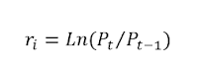

The graph below shows the cumulative sum of returns for the stocks listed in VCBF-BCF’s portfolio.

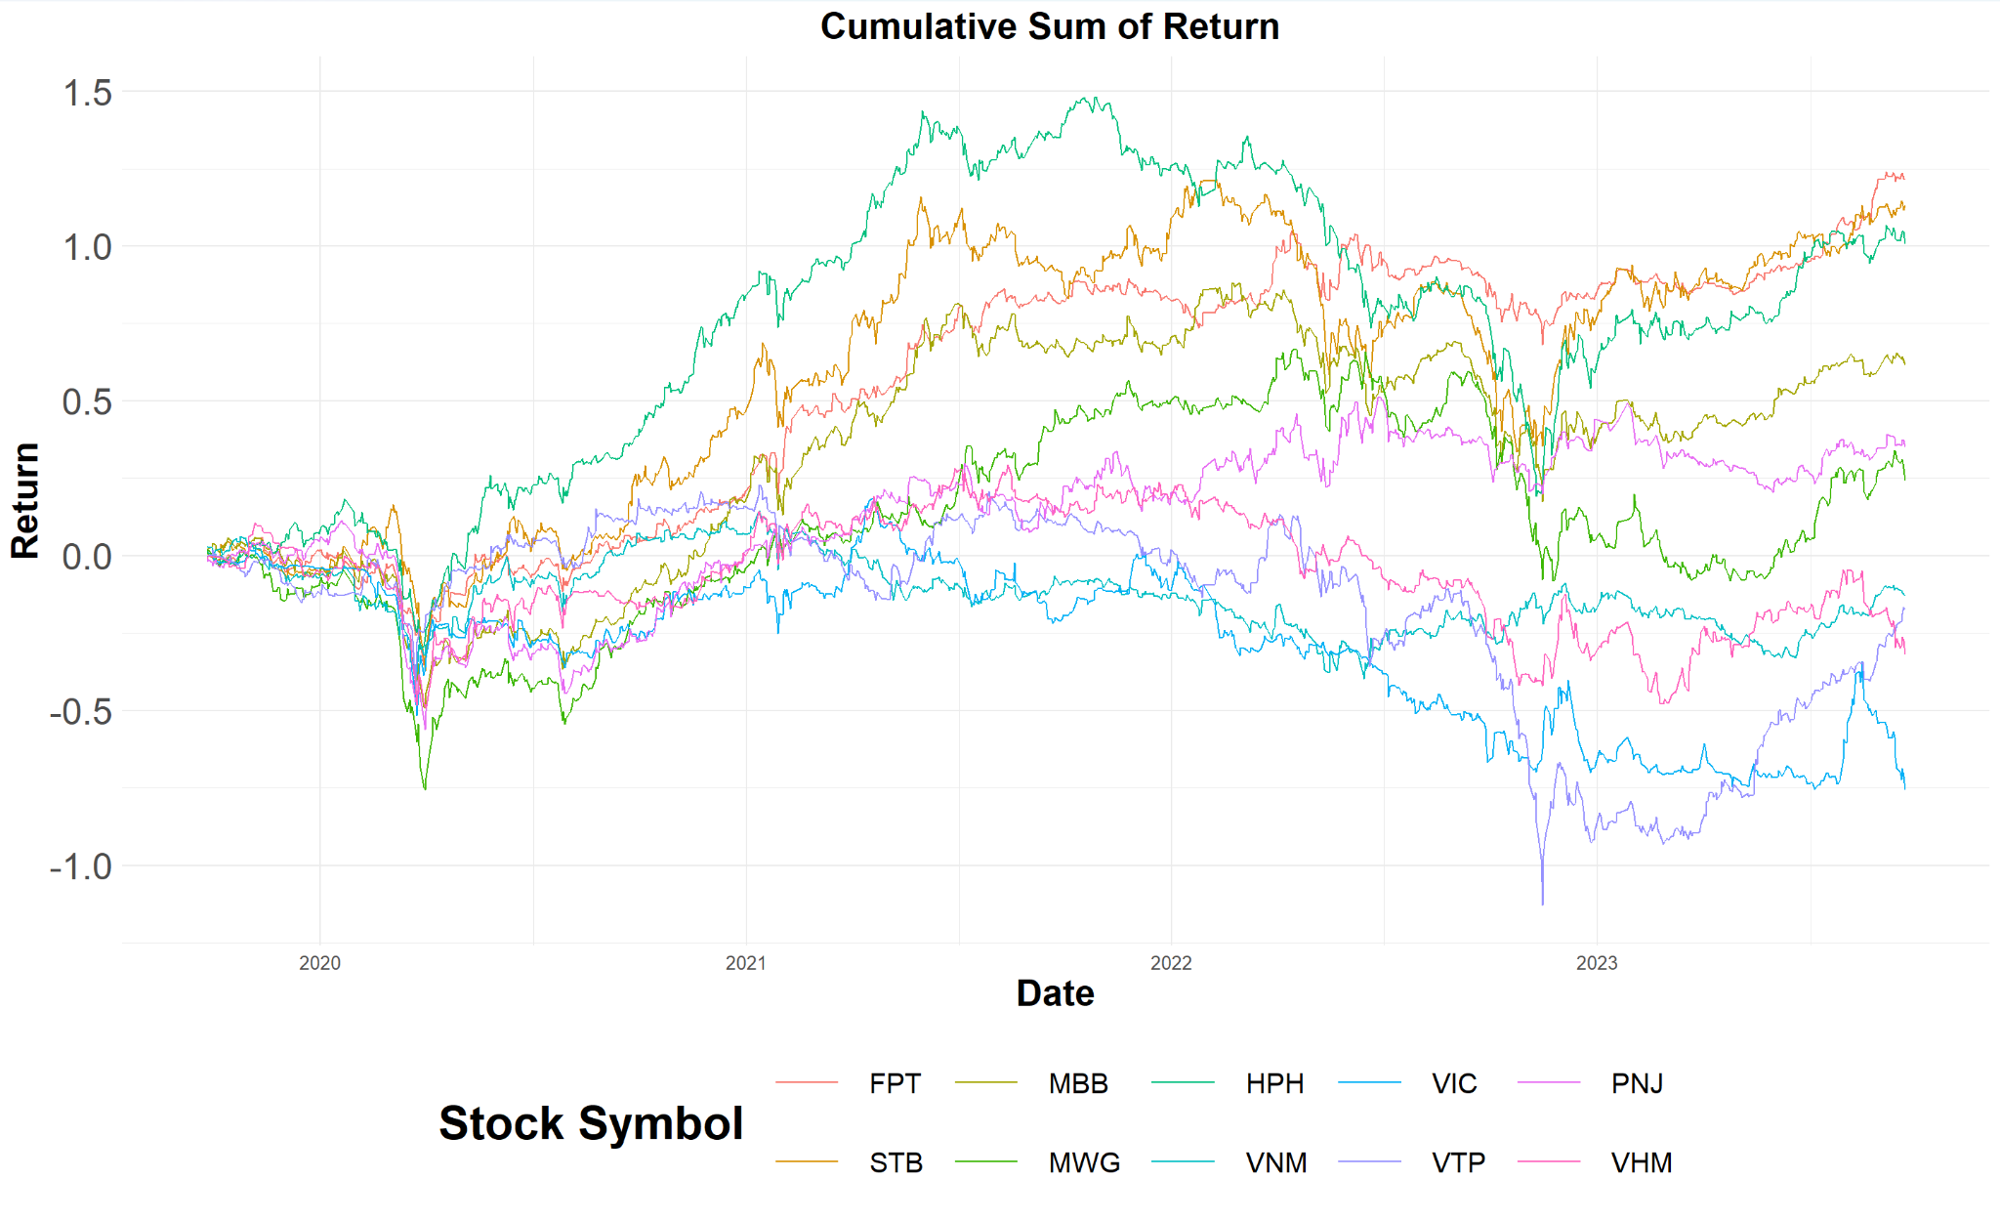

The entire process of our portfolio construction will be conducted in R programming language. The first step is to construct a correlation matrix to see if the portfolio’s stocks are diversified enough.

## 3. Stocks Correlation

## 

Correlation between stocks in a portfolio measures the degree to which the returns of the stocks move in tandem. A correlation coefficient of 1 implies that the returns move perfectly in sync, -1 means they move in exactly opposite directions, and a value of 0 suggests no relationship between the returns.

A high correlation between stocks in a portfolio is generally undesirable for various reasons. Firstly, the primary reason investors hold multiple stocks in a portfolio is to benefit from diversification. If stocks are highly correlated, the diversification benefits are minimized. helps in reducing the portfolio's overall risk because different stocks or sectors may react differently to the same economic event. Secondly, if all stocks in a portfolio are highly correlated and move in the same direction, the risk is concentrated. In a downturn, if one stock suffers, it's likely that others will follow suit, leading to significant losses.

A good correlation between stocks is often below 0.7. As we can see in the heatmap above, only the two stocks, STB and MBB, have a slightly above-desirable correlation with a value of 0.72, which can be explained because these two belong to the same banking industry. The rest of the stocks have correlations below 0.7, indicating a well-diversified portfolio.

## 4. Portfolio Optimization (GMV, Optimal, Equal-weight)

For constructing this CML, the risk-free rate we use is the 10-year Vietnamese government bond yield, reported as 2.741% on 22/09/2023. Keep in mind that because Vietnamese stock markets prohibit short selling, this efficient frontier is constructed using long-purchase only. 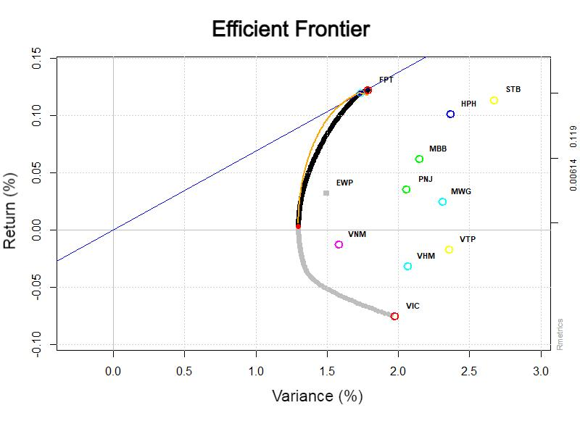

The efficient frontier of the ten stocks is shown in the graph above. The red dot in the middle of the frontier marks the GMV portfolio, known as the Global Minimum Variance Portfolio. The gray square shows the location of the EWP (Equally-Weighted Portfolio), while the blue line coming in from the bottom left corner is the Capital Market Line. Finally, the optimal portfolio is the tangent point of the frontier with the CML.

Next, we will delve into more details about these specific portfolio allocations.

### Equally-Weighted Portfolio

The expected return of the EWP portfolio is 0.032 (or 3.2%) and a variance risk of 1.496%. Moreover, this portfolio has a CVaR of 4.161, suggesting that in the worst scenarios, the expected loss can be quite significant. In addition, VaR is a measure that provides an estimate of the maximum potential loss of a portfolio over a given time period for a given confidence interval. The EWP has a 95% VaR of 2.771 means that there are 5% that the portfolio will lose more than 2.771% over the specified time period (often a day or a year).

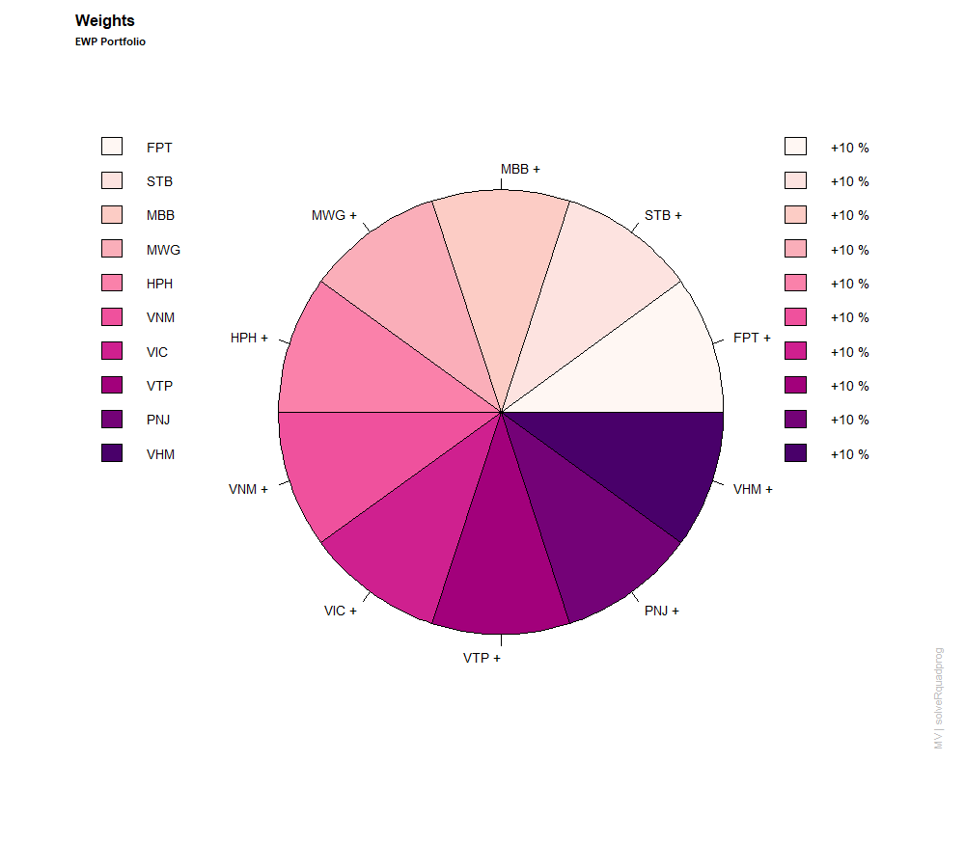

For the equally-weighted portfolio, the proportion for each stock is equally distributed. Because this portfolio has ten stickers, the weight of each individual stock is 10%.

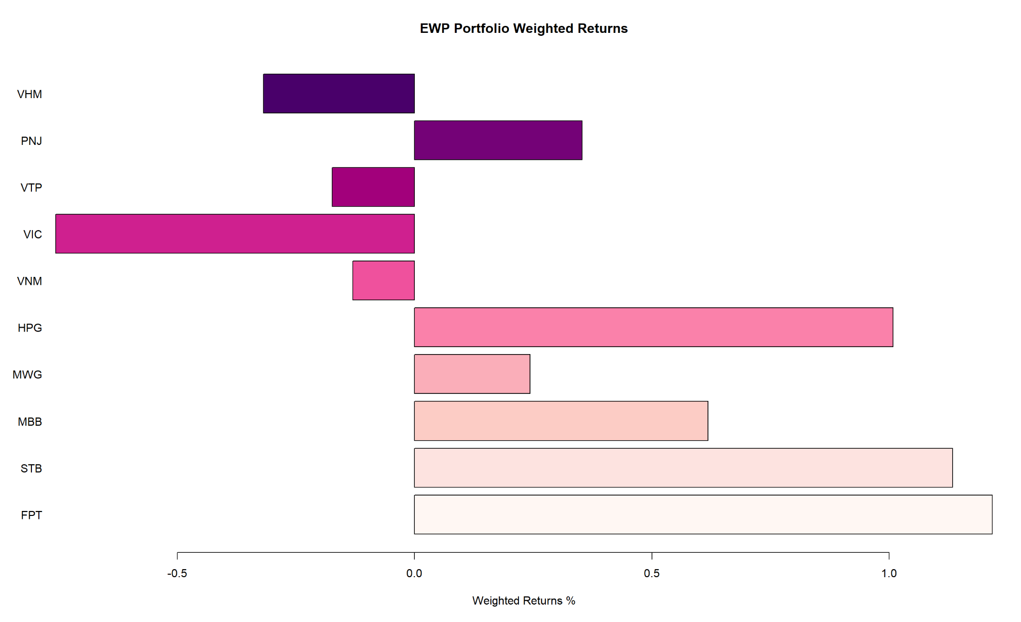

The barplot above shows the weighted returns of these ten stocks, as in the contribution of each stock to the overall portfolio’s performance. In this particular portfolio, we can see the highest contributions belong to FPT, STB, MBB, and HPG, while there are four stocks that negate the return of the portfolio, which are VIC, VHM, VTP, and VNM in that order.

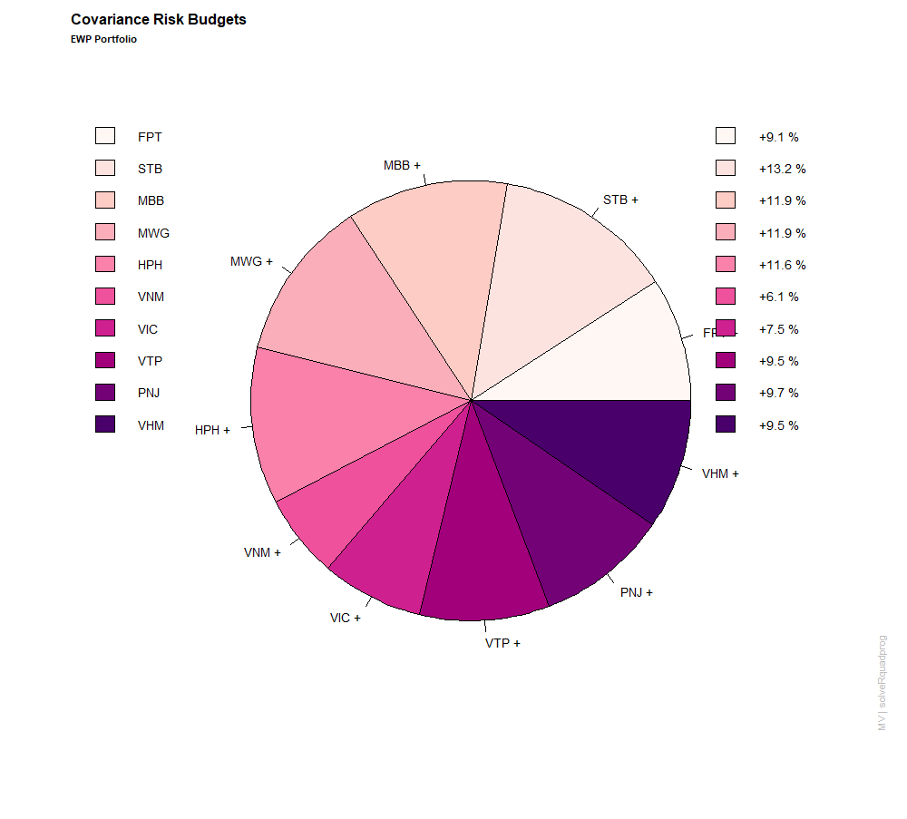

The pie chart shows the distribution of variance risk budgets. Generally, it is equally distributed. The highest contribution to the risk is MBB, with a value of 13.2%. Assets like STB, MWG, HPH, VTP, PNJ, and VHM also have slightly lower risk budgets, ranging between 0.095 and 0.132. This suggests that these assets play a pivotal role in contributing to the portfolio's overarching risk. On the other end of the spectrum, assets like VNM have a risk budget of 0.061, indicating a relatively smaller contribution to the portfolio's risk.

### Global Minimum Variance Portfolio

The expected return of the GMV portfolio is 0.0028 or 0.28%. While this may seem modest at first glance, it's crucial to remember that the primary objective of the GMV portfolio is risk minimization, not return maximization. The positive return, albeit slight, indicates that the portfolio is designed to provide some growth while primarily safeguarding against excessive volatility.

The variance is calculated at a very low value of 1.2985. Given that this is a GMV portfolio, the covariance risk is expected to be at its lowest compared to other portfolios on the efficient frontier. The CVaR, or Expected Shortfall, is calculated at 3.3548. The portfolio's 95% VaR stands at 1.9674. This metric offers a probabilistic risk assessment, suggesting that the portfolio is unlikely to incur a loss exceeding 1.9674% over a defined period at a specific confidence level. It's a snapshot of the "worst-case scenario" loss that an investor might anticipate.

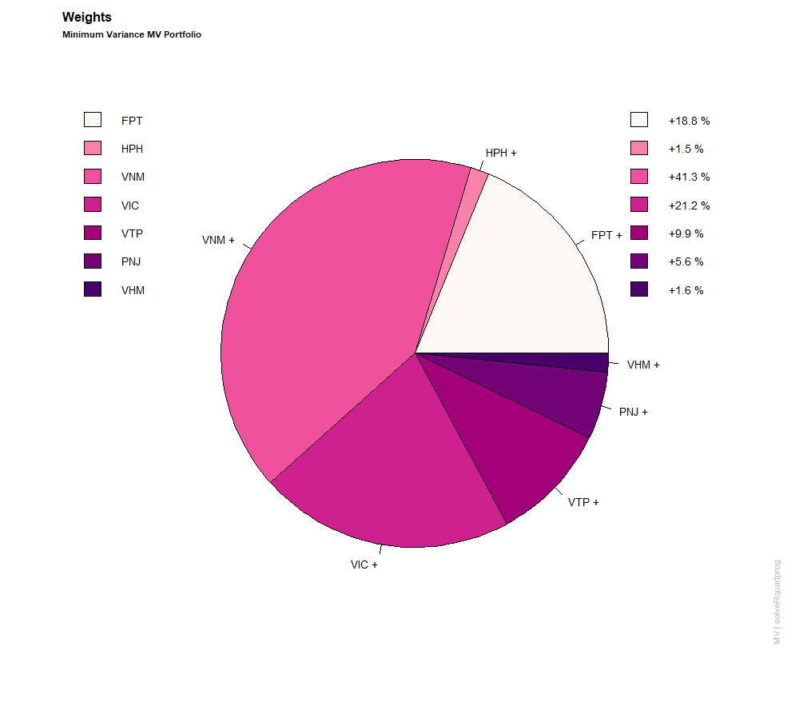

The pie chart illustrates the distribution of assets within a GMV portfolio, represented by their respective weightings. These weightings signify the proportion of the total portfolio value that each asset constitutes.

Overall, the portfolio exhibits a diverse range of weightings, with VNM having the highest share at 41.3%, while STB has no allocation, indicating an absence of this asset in the portfolio.

VNM dominates the portfolio with a substantial weighting of 41.3%, suggesting that it constitutes a significant portion of the portfolio's total value. VIC and FPT have weightings of 21.2% and 18.8%, respectively, indicating a substantial presence in the portfolio but not as dominant as VNM.

Minor Allocations: HPH, VTP, PNJ, MWG, and VHM collectively account for the remaining 18.7% of the portfolio, with each having relatively minor contributions.

Comparing VNM's substantial allocation to STB's absence in the portfolio, there is a stark contrast, reflecting varying levels of importance and risk exposure within the portfolio.

In conclusion, this distribution of Portfolio Weights showcases a diversified investment approach, with some assets like VNM playing a pivotal role in the portfolio's overall value, while others have more modest contributions. This diversification can help manage risk and potentially optimize returns.

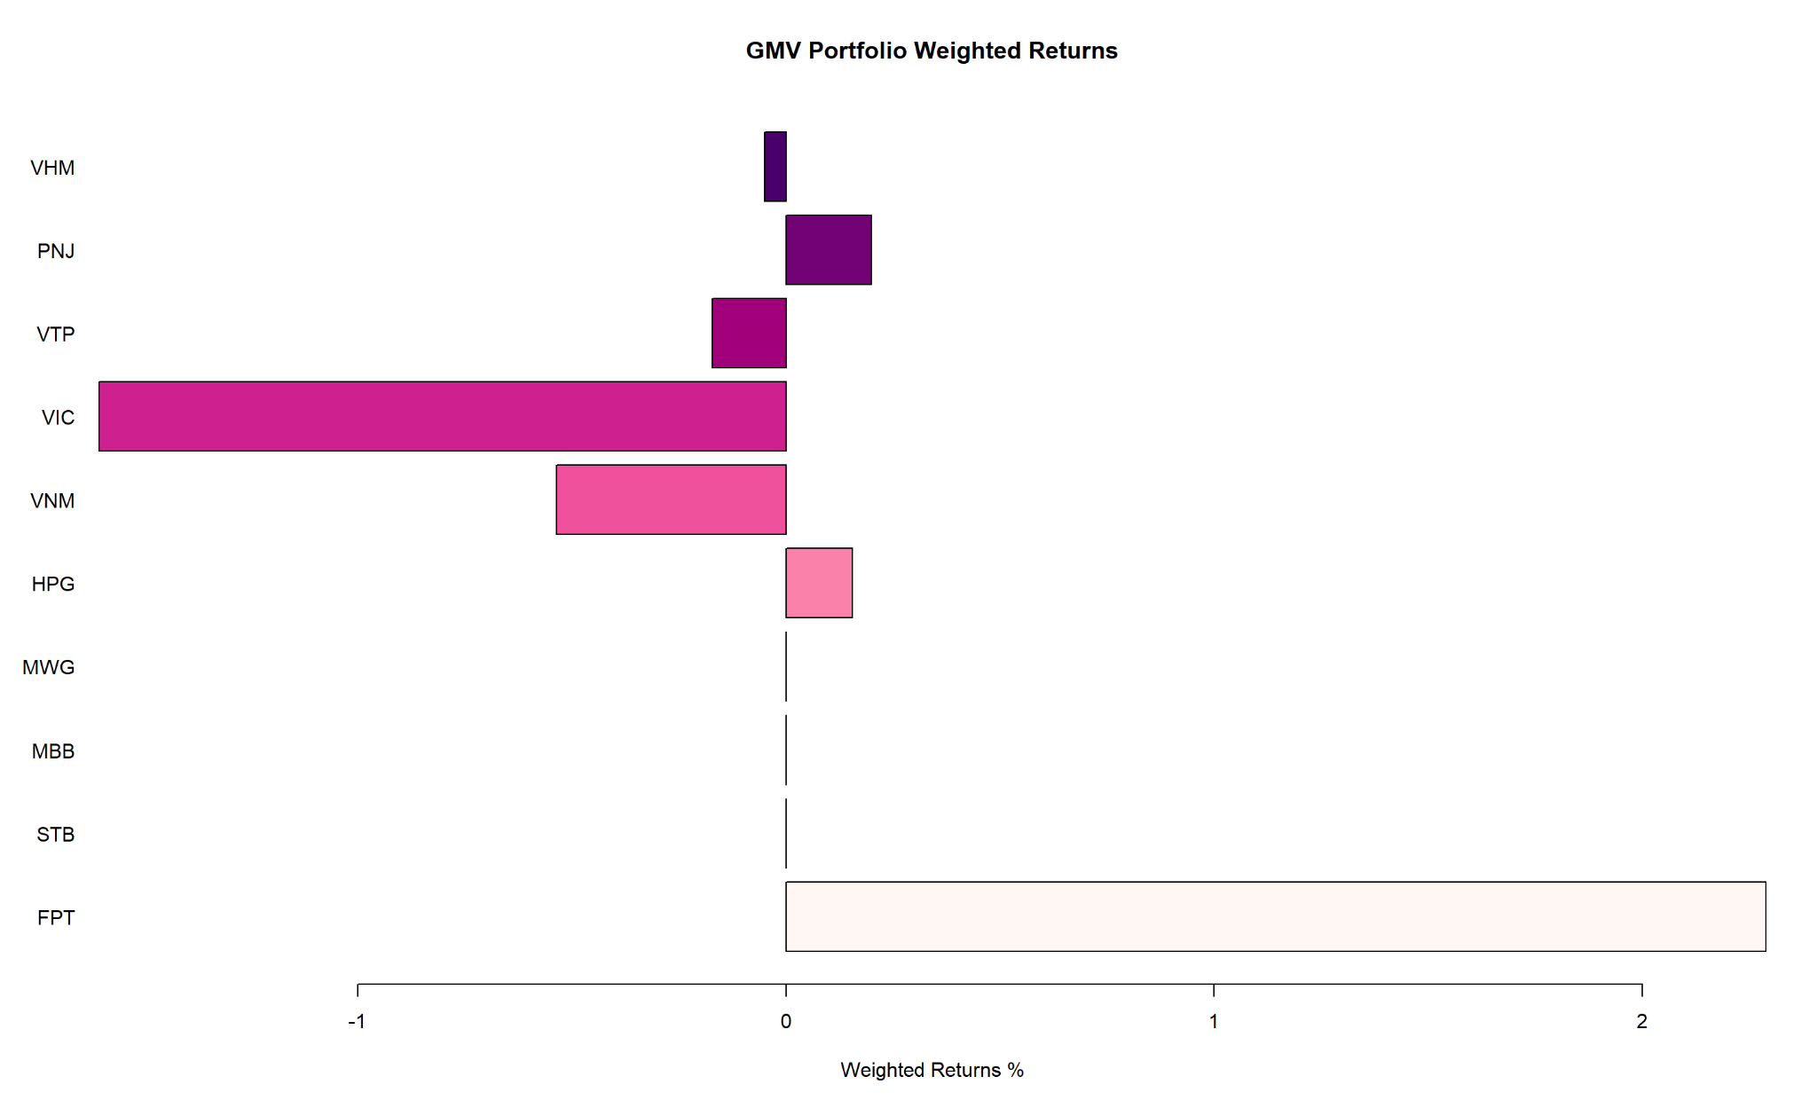

The pie chart illustrates the returns of different assets within a GMV portfolio, represented by their respective weights. These weighted returns provide insight into the contribution of each asset to the portfolio's overall performance.

Overall, the returns vary significantly across the assets. While some assets have positive returns, others have negative returns, and some have no contribution at all.

FPT has the highest positive weighted return at 2.289, indicating it has made a substantial positive contribution to the portfolio's performance. HPH and PNJ also have positive returns, albeit smaller.

On the other hand, VNM and VIC have notably negative weighted returns of -0.537 and -1.605, respectively, signifying that they have detracted from the portfolio's overall returns.

STB, MBB, MWG, VTP, and VHM have zero weighted returns, suggesting they neither positively nor negatively impact the portfolio's performance.

Comparing FPT's significant positive return to VIC's substantial negative return, there is a stark contrast in their contributions to the portfolio. This divergence in performance highlights the importance of asset selection and allocation in portfolio management.

In short, this analysis of weighted returns within the global minimum variance portfolio underscores the diversity of asset performance. While some assets have contributed positively, others have detracted from the portfolio's overall returns. Effective portfolio management involves optimizing these weights to achieve the desired risk-return profile.

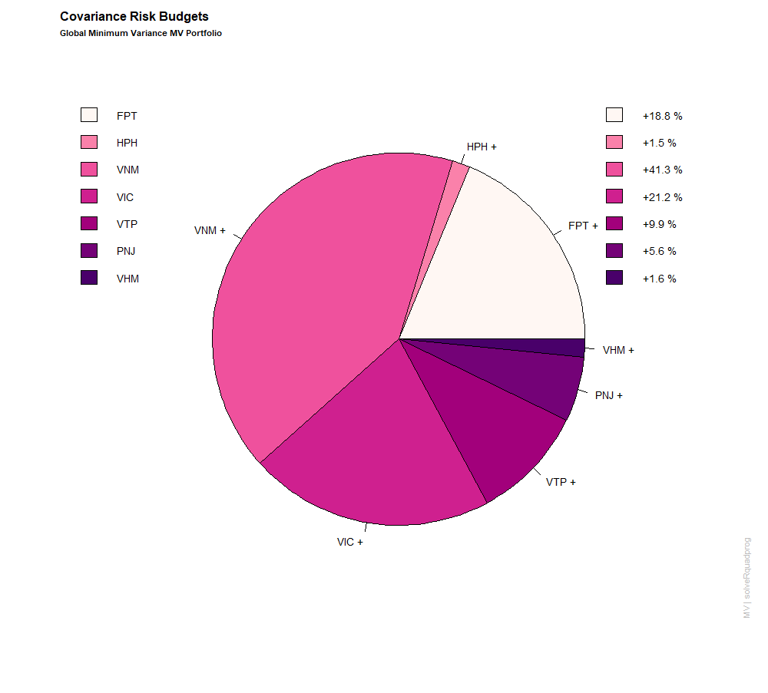

The pie chart illustrates the distribution of Variance Risk Budgets across ten different assets within a global minimum variance portfolio. These percentages represent the proportion of risk allocated to each asset, contributing to the portfolio's overall risk management. Overall, the allocation of risk budgets within the portfolio demonstrates a diversified approach, with VNM having the highest risk budget at 41.3%, while STB has no risk allocation, indicating its absence in the portfolio.

VNM emerges as the asset with the highest variance risk budget at 41.3%, signifying its substantial contribution to the portfolio's overall risk.

Moderate Risk Assets: VIC and FPT have variance risk budgets of 21.2% and 18.8%, respectively, indicating significant risk exposure but not to the extent of VNM.

HPH, VTP, PNJ, MWG, and VHM collectively account for the remaining 17.7% of the portfolio's risk budget, with each asset having relatively minor risk contributions.

In conclusion, the allocation of Variance Risk Budgets within this global minimum variance portfolio reflects a diversified risk management strategy. Some assets, such as VNM, carry significant risk exposure, while others have more moderate or minimal risk contributions. This diversified approach aims to balance risk and optimize the portfolio's overall risk-return profile.

### Optimal Portfolio

The optimal portfolio, or the tangent portfolio that is located at the tangent point between the CML and the efficient frontier, has a projected return that stands at an impressive 0.12 (or 12%). The variance is at 1.73. The CVaR of this particular combination weight of this portfolio is 4.36%, meaning in the worst-case scenarios, investors will suffer a loss of 4.36%.

The 95% VaR stands at 2.67, suggesting that there is a 95% likelihood that the portfolio will not suffer a loss exceeding 2.67% over a defined period.

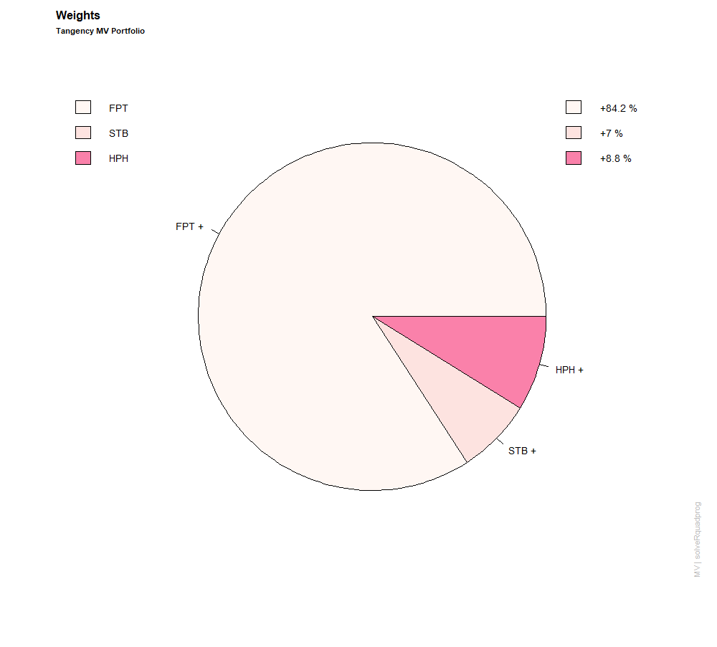

In the tangent portfolio, there's a striking disparity in the distribution. FPT dominates with a weight of 0.842 (or 84.2%), making it the primary constituent. This is followed by STB and HPG with weights of 0.070 (or 7%) and 0.088 (or 8.8%), respectively. All other assets, namely MBB, MWG, VNM, VIC, VTP, PNJ, and VHM, have zero weights, indicating their exclusion from the tangent portfolio. Such a concentration on a few assets underscores the portfolio's reliance on them for its performance.

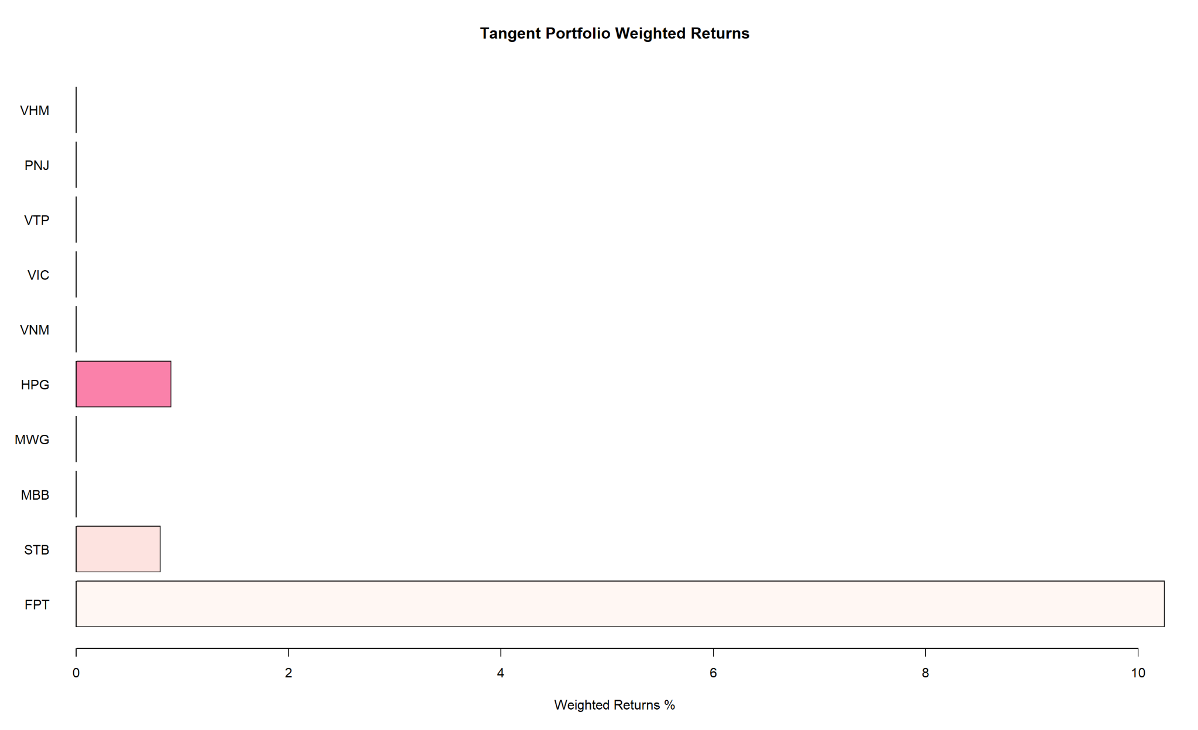

The tangent portfolio weight returns graph shows us that in the 12% of the portfolio’s return, FPT contributes more than 10% of that while HPG and STB only add approximately 1%. All the other stock weighted returns are at 0, showing no contribution to the tangent portfolio’s return at all.

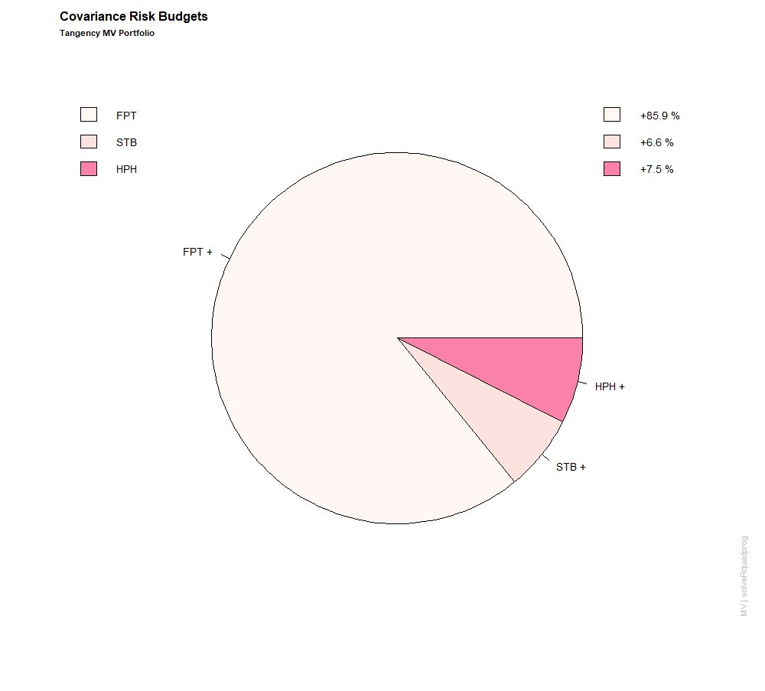

FPT carries the highest risk budget of 0.859, aligning with its dominant position in the portfolio. This is followed by STB and HPG with risk budgets of 0.066 and 0.075, respectively. The risk budgets of all other assets remain zero, which is consistent with their zero weights. This signifies that the portfolio's overall risk is primarily influenced by the three aforementioned assets.

The summarized table below of all these three types of portfolios that have just been discussed:

|  |  |  |  |
| --- | --- | --- | --- |
|  | **EWP** | **GMV** | **Optimal** |
| **Expected return** | 0.032% | 0.0028% | 0.12% |
| **Var (%)** | 1.496 | 1.2985 | 1.73 |
| **CVaR (%)** | 4.161 | 3.3548 | 4.36 |
| **95% VaR (%)** | 2.771 | 1.9674 | 2.67 |

The Optimal portfolio clearly stands out with the highest expected return of 0.12%, which is significantly greater than both the EWP (0.032%) and GMV (0.0028%). This suggests that the Optimal portfolio is the most lucrative option, while the GMV offers the lowest potential reward. The EWP offers a moderate return in comparison.

The variance (Var) measures the dispersion of returns of a portfolio. The Optimal portfolio has the highest variance at 1.73%, implying that it might have the highest volatility or risk compared to the other two portfolios. The GMV has the lowest variance at 1.2985%, suggesting it might be the most stable portfolio in terms of fluctuations, while EWP's variance is a bit higher than GMV's but still lower than the Optimal portfolio.

The Conditional Value at Risk (CVaR), also known as Expected Shortfall, gives an idea of the expected loss on the worst days. The Optimal portfolio has the highest CVaR at 4.36%, meaning that its potential losses during extreme adverse movements are the greatest among the three portfolios. EWP's CVaR is slightly lower at 4.161%, and GMV offers the lowest CVaR at 3.3548%, indicating it might have the least potential losses during extremely bad market days.

The Value at Risk (VaR) at the 95% confidence level provides an estimate of the potential loss over a specified period for a given confidence interval. The EWP has the highest 95% VaR at 2.771%, suggesting that it faces the most risk of experiencing significant losses. The GMV portfolio has the lowest 95% VaR at 1.9674%, indicating it's the least risky in this context, while the Optimal portfolio's 95% VaR is slightly lower than EWP's but higher than GMV's.

## 5. Performance Analysis (Key Performance Indicators)

After we have chosen the optimal portfolio, it is necessary to evaluate the performance of that portfolio. In this part, we will conduct an evaluation against the market, which will be represented by the VN100 index, and the fund’s performance, which is shown through the data of its NAVPS.

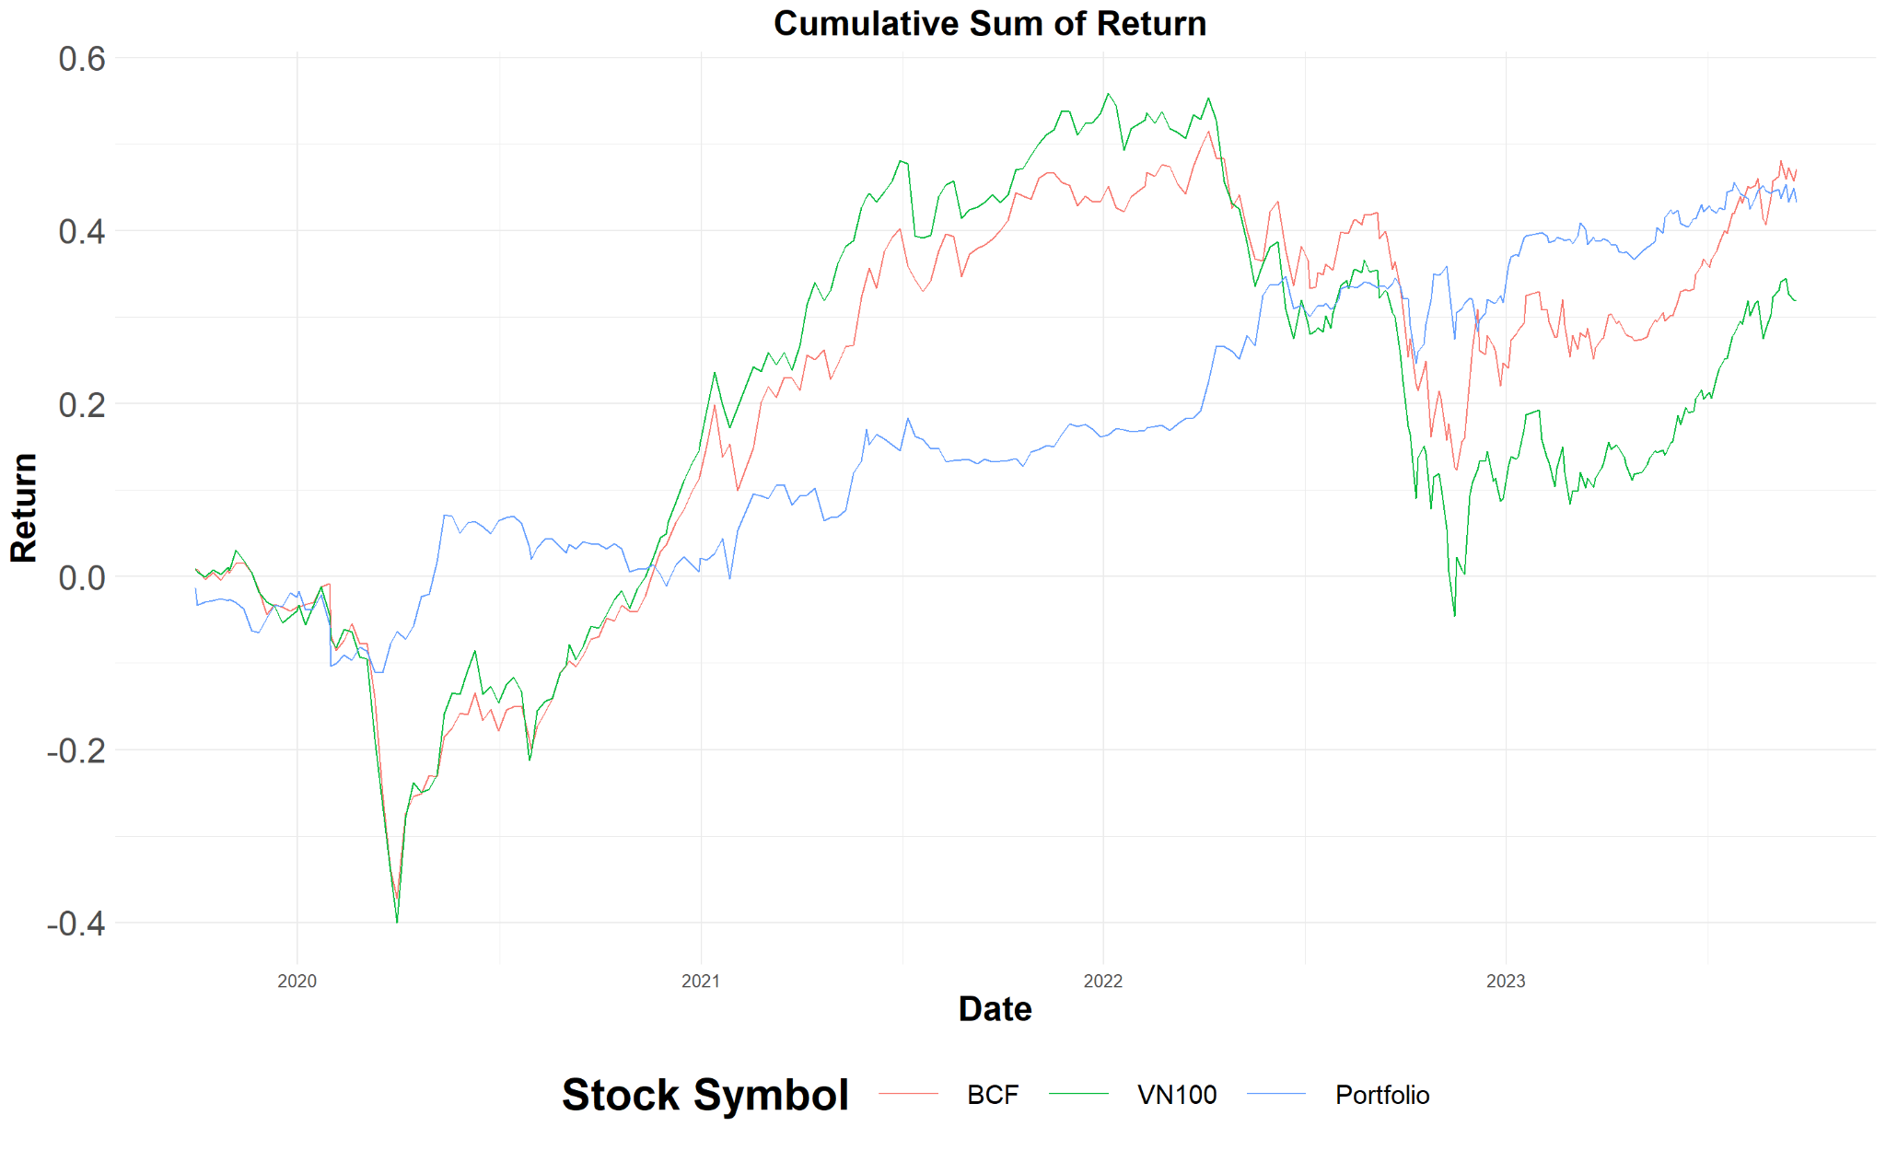

From the graph above, we can see over the period, the blue line, which indicates the portfolio’s cumulative sum of returns, grew gradually, while the other two lines fluctuated noticeably. One reason for this instance could be that the composition of a portfolio plays a pivotal role in determining its risk and return profile. At the end of the period, BCF and portfolio won the VN100. The gradual growth of the blue line suggests a well-diversified portfolio that spreads its risk across various asset classes, sectors, or geographies. Such diversification can help mitigate the impact of any single underperforming asset or sector.

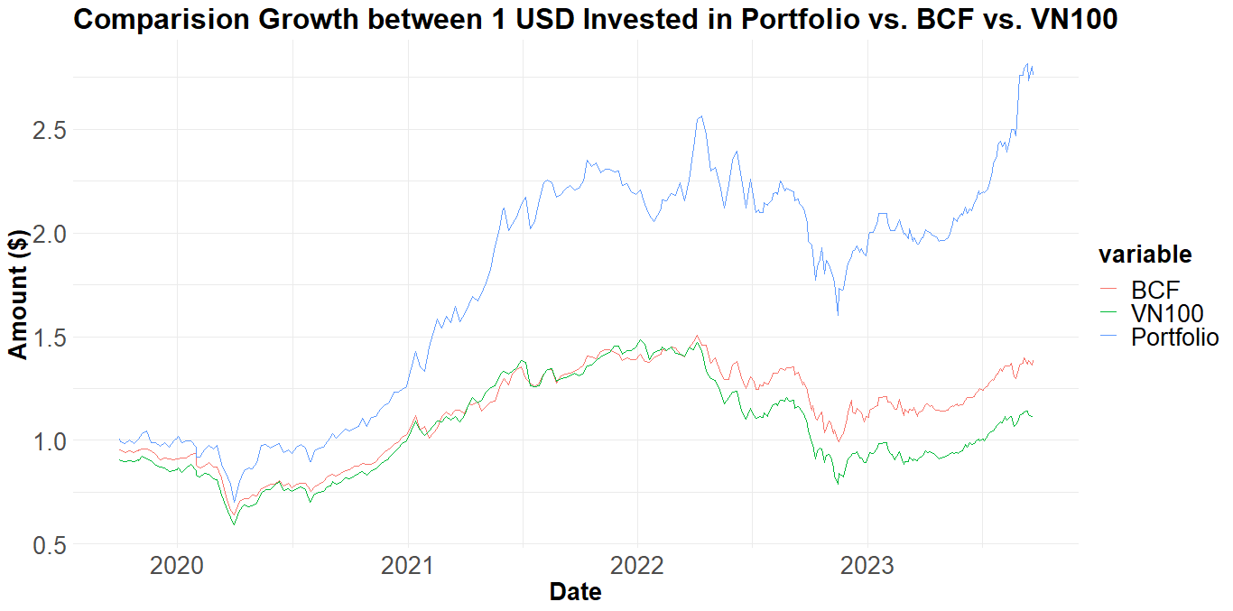

From the graph above, we can see over the period, the blue line, which indicates the portfolio’s comparison growth of returns, grew gradually, while the other two lines fluctuated noticeably below the portfolio. Because of its steady and gradual growth, the portfolio outperforms both VN100 and BCF.

In the previous section, we have introduced the use of KPIs in portfolio performance evaluation. The table below summarizes various crucial metrics to further assess our portfolio performance:

|  | **Portfolio** | **VBCF-BCF** | **VN100** |
| --- | --- | --- | --- |
| Alpha | 0.0013 | 0.00087 | 0 |
| Beta | 0.17 | 0.69 | 1 |
| Maximum Drawdown | 0.098 | 0.34 | 0.47 |
| Treynor Ratio | 0.0085 | 0.0023 | 0.0015 |

The alpha metrics provide insights into the risk-adjusted performance of the investments relative to the market. The portfolio's alpha is 0.0013, and BCF's alpha is 0.00087. Both positive alphas suggest that the portfolio and BCF stock have outperformed the market on a risk-adjusted basis. However, the portfolio's alpha is higher than BCF's, indicating that it has generated a slightly superior excess return relative to the market than BCF has, after accounting for their respective risks.

The portfolio has a beta of 0.17, indicating it is considerably less sensitive to market movements than the market itself. This implies the portfolio tends to be more stable and less affected by overall market volatility. On the other hand, BCF stock has a beta of 0.69, suggesting it is more responsive to market changes than the portfolio but still less volatile than the market. A beta of less than 1 for both the portfolio and BCF indicates that they both generally exhibit less volatility than the market.

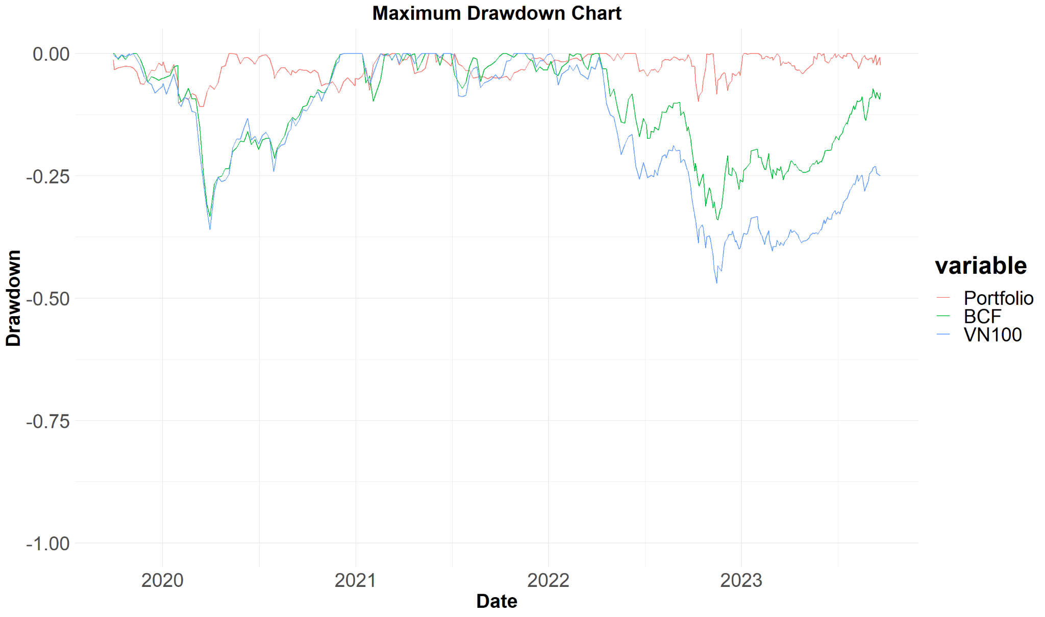

Our portfolio's maximum drawdown of 9.8% is notably lower than that of both the BCF fund, which experienced a 34% max drawdown, and the VN100 market index, which saw a staggering 47% decline. This indicates that this portfolio exhibited a significantly reduced downside risk and volatility in comparison to both VCBF-BCF and the broader market, suggesting that our optimization strategy has managed to shield our portfolio from the more substantial declines that impacted other investments, showcasing its resilience in potentially turbulent market conditions.

The Treynor Ratio measures the risk-adjusted performance of investments considering the systematic risk (beta). A higher Treynor Ratio indicates better performance for a given level of risk. The portfolio's Treynor Ratio is 0.0085, which is significantly higher than both BCF's Treynor Ratio of 0.0023 and the market's Treynor Ratio of 0.0015. This suggests that the portfolio has provided a better return per unit of systematic risk than both BCF and the market.

In short, the portfolio demonstrates superior performance metrics across all three parameters when compared to BCF and the market. BCF, while outperforming the market in terms of alpha and Treynor Ratio, falls short of the portfolio's performance metrics.

# Conclusion

VCBF-BCF is one of the most well-known and profited open-ended funds in Vietnam. The fund’s strategy is to use a bottom-up approach and reallocate the portfolio across sectors and companies throughout each economic period. Based on the ten most-invested stocks in the fund’s portfolio, we have used the programming language R and Markowitz’s Portfolio Theory Programming to construct an optimal portfolio. Overall, our portfolio is shown to outperform both the market and the VCBF-BCF fund, with an expected return of 12% and a well-risk-return balanced variance of 1.73%. It's worth noting that not all stocks from the initial list feature in the final portfolio, as several have zero weightages. In addition, because of the prohibition of short-selling in the Vietnamese stock market, the optimal portfolio might not have the highest possible Sharpe ratio and is still leaving room for better optimization.